Vegan Chocolate Vending Machine

Unit Test (JavaScript)

Developer: Edgar Francis A. Felix

Date: 4/17/2019

|  |  |  |  |
| --- | --- | --- | --- |
| **Item #** | **Description** | **Status** | **Comments** |
| 1 | Heading information: | Pass |  |
| 1.1 | title is shown. | Pass |  |
| 1.2 | menu items are listed. | Pass |  |
| 1.3 | accepted coins are listed. | Pass |  |
| 1.4 | “Cancel” button is shown. | Pass |  |
| 1.5 | format of box and text are in correct. | Pass |  |
| 1.5 | welcome message is shown | Pass |  |
| 2 | Inserted valid coins: | Pass |  |
| 2.1 | total coins inserted is shown. | Pass |  |
| 2.2 | accepts all valid coins and adds them to the total coins correctly. | Pass |  |
| 3 | Inserted 5C coins: | Pass |  |
| 3.1 | user is informed that its not accepted by the machine. | Pass |  |
| 3.2 | 5C coin is returned. | Pass |  |
| 3.3 | list of valid coins are displayed. | Pass |  |
| 3.4 | total coins did not change. | Pass |  |
| 3.5 | all notification are properly aligned and indented. | Pass |  |
| 4 | Invalid inputs: | Pass |  |
| 4.1 | user is informed that input is not valid. | Pass |  |
| 4.2 | invalid coin is returned. | Pass |  |
| 4.3 | list of valid coins are displayed. | Pass |  |
| 4.4 | total coins did not change. | Pass |  |
| 4.5 | all notification are properly aligned and indented. | Pass |  |
| 5 | Total coins inserted is equals or greater than the price of a menu item: | Pass |  |
| 5.1 | menu item is listed. | Pass |  |
| 6 | The user selects a menu item and the total inserted coins are exactly the same as the selected item price: | Pass |  |
| 6.1 | correct item is dispensed. | Pass |  |
| 6.2 | exit message is displayed. | Pass |  |
| 6.3 | a new transaction is initiated. The total coin is zero and all the select buttons of the menu items are disabled. | Pass |  |
| 7 | The user selects a menu item and the total inserted coins are greater than the selected item price: | Pass |  |
| 7.1 | correct item is dispensed. | Pass |  |
| 7.2 | correct change is dispensed. | Pass |  |
| 7.3 | exit message is displayed. | Pass |  |
| 7.4 | a new transaction is initiated. The total coin is zero and all the select buttons of the menu items are disabled. | Pass |  |
| 8 | The user cancels the transaction: | Pass |  |
| 8.1 | unused coins are dispensed. | Pass |  |
| 8.2 | exit message is displayed. | Pass |  |
| 8.3 | a new transaction is initiated showing the heading and prompt. | Pass |  |

## Item # 1: Heading information.

Step 1: Open the webpage index.html on your browser.

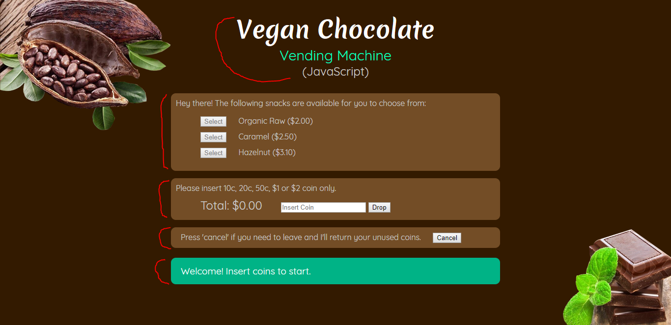

Result:

1.1 - The title is shown correctly.

1.2 - Menu items are complete. The names and prices are correct.

1.3 - The accepted coins are listed correctly.

1.4 - The ‘cancel’ button is shown and described appropriately.

1.5 - The surrounding box is in order and appropriate spacing is observed for padding and margin.

1.6 - Welcome message is displayed.

## Item # 2: Inserted valid coins.

Step 1: In the coin slot field, enter the value “10c”, “20c”, “50c”, “$1”, “$2” sequentially.

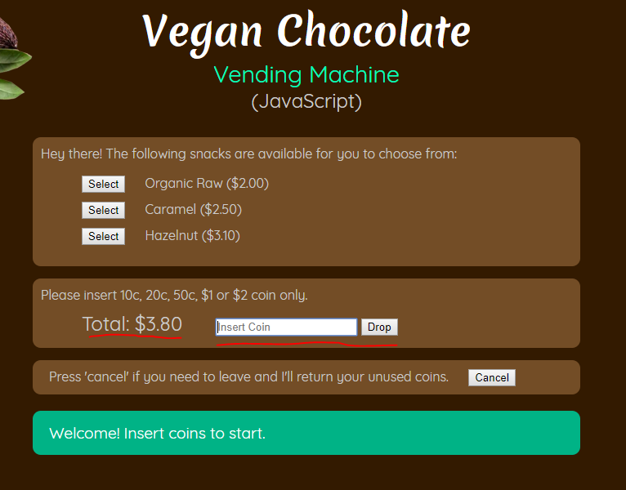

Result:

2.1 - The total coins is shown.

2.2 - All valid coins are correctly captured and added to the total coins correctly.

## Item # 3: Inserted 5C coins.

Step 1: Enter “5C”.

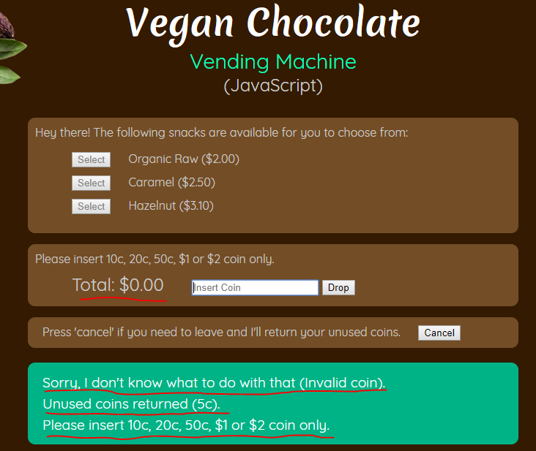

Result:

3.1 - The user is informed that 5c coin is not valid.

3.2 - The 5c coin is returned.

3.3 - The list of valid coins are displayed.

3.4 - The total coins did not change.

3.5 - All notifications from machine are aligned and indented correctly.

## Item # 4: Invalid inputs.

Step 1: Enter “asdf”.

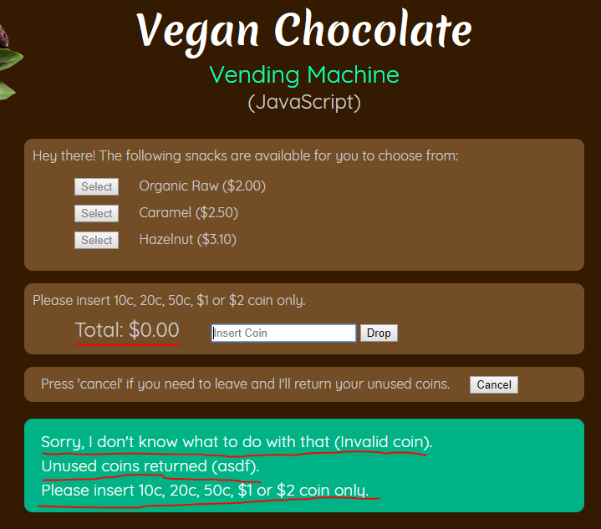

Result:

4.1 - The user is informed that the input is not valid.

4.2 - The coin is returned.

4.3 - The list of valid coins are displayed.

4.4 - The total coin did not change.

4.5 - All notifications from machine are aligned and indented correctly.

## Item # 5: Total coins inserted is equals or greater than the price of a menu item, the menu item should be displayed as available for purchase.

Step 1: Click “cancel” to make sure the total coins is zero.

Step 2: Enter “$2”.

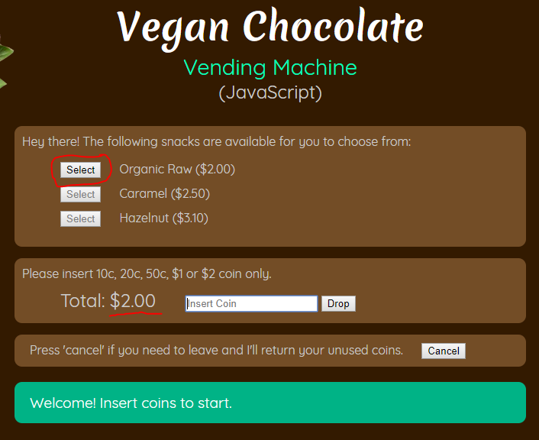

Step 3: Enter “50c”.

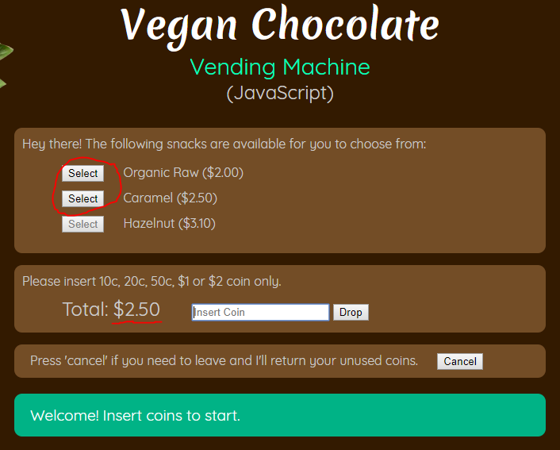

Step 4: Enter “50c” then “10c”.

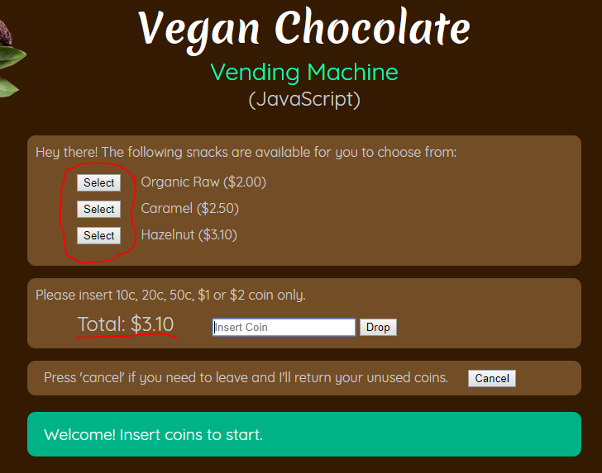

Result:

5.1 - Menu items are shown when there is enough coins to purchase the item.

## Item # 6: User selects a menu item and the total inserted coins are exactly the same as the selected item price.

Step 1: Enter “cancel” to clear total coins.

Step 2: Enter “$2”.

Step 3: Enter click the select button of “Organic Raw” menu item.

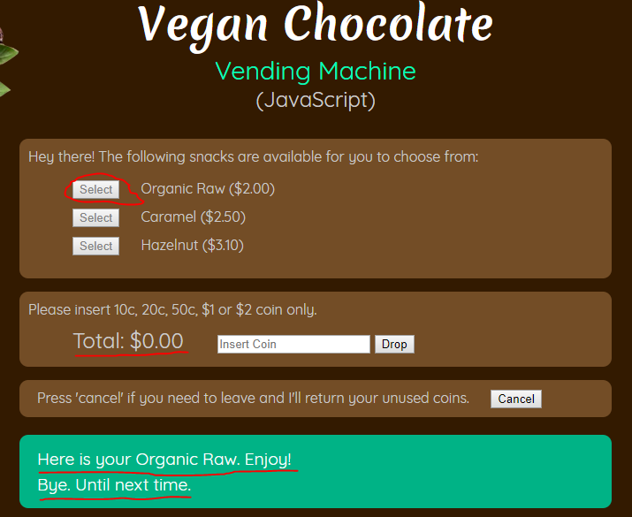

Step 4: Enter “$2” then “50c”.

Step 5: Enter “b” to select “Caramel” menu item.

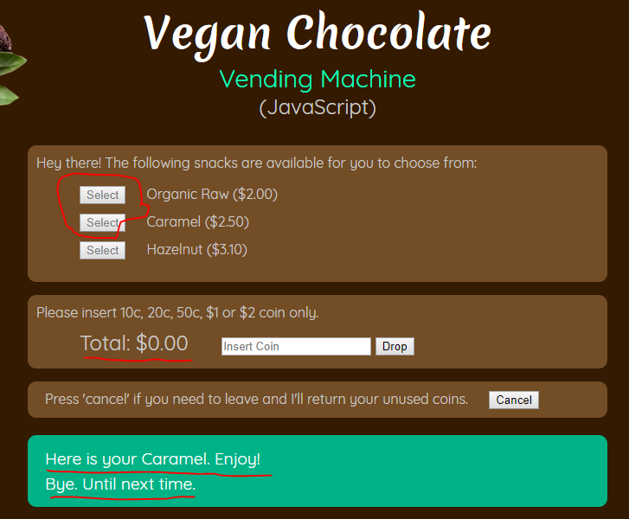

Step 6: Enter “$2” then “$1” then “10c”.

Step 7: Enter “c” to select “Hazelnut” menu item.

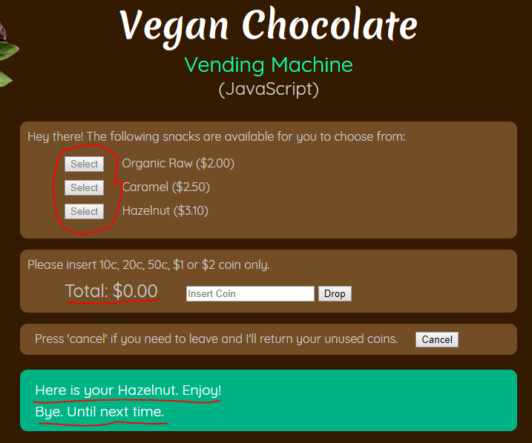

Result:

6.1 - The correct item is dispensed.

6.2 - The exit message is displayed.

6.3 - A new transaction is initiated. The total coin is zero and all the select buttons of the menu items are disabled..

## Item # 7: User selects a menu item and the total inserted coins are greater than the selected item price.

Step 1: Click “cancel” to clear total coins.

Step 2: Enter “$2” and “10c”.

Step 3: Enter “a” to select “Organic Raw” menu item.

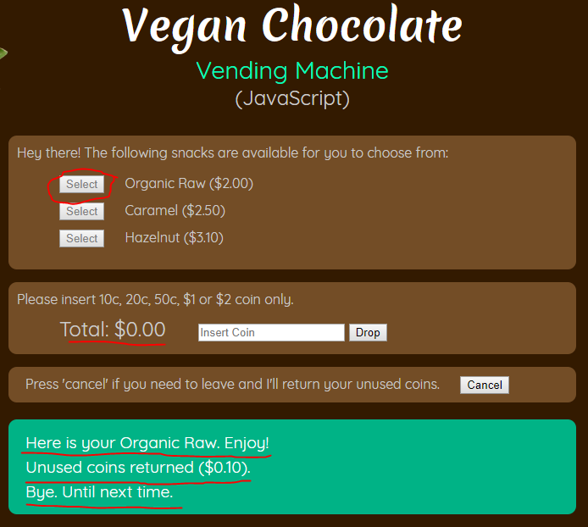

Step 4: Enter “$2” then “$1”.

Step 5: Enter “b” to select “Caramel” menu item.

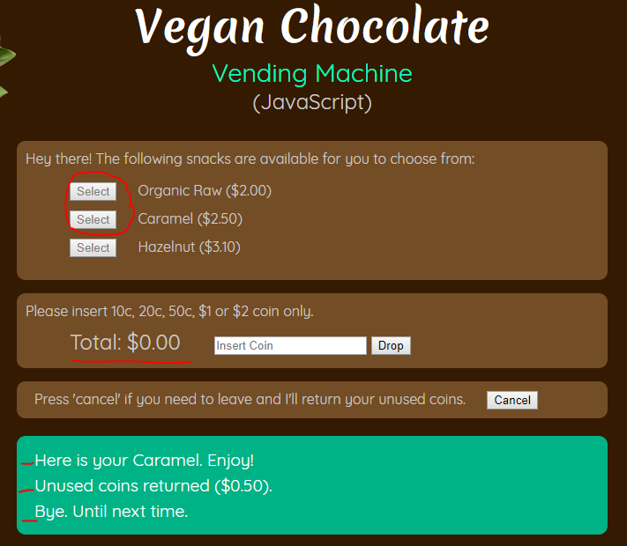

Step 6: Enter “$2” then “$2”.

Step 7: Enter “c” to select “Hazelnut” menu item.

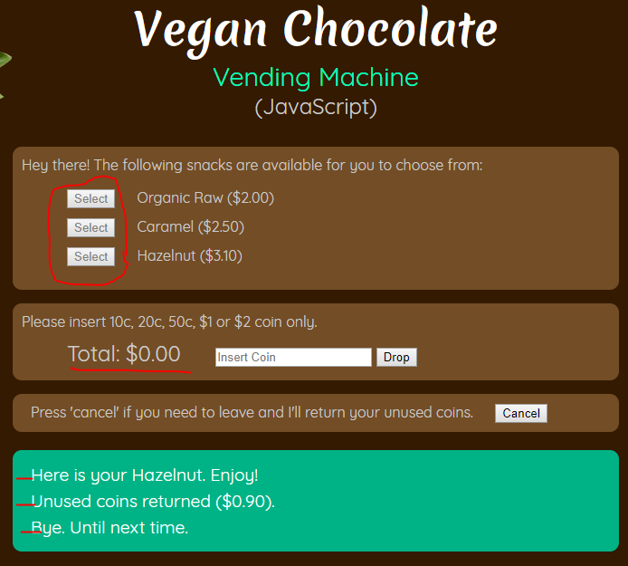

Result:

7.1 - The correct item is dispensed.

7.2 - The correct change is dispensed.

7.3 - The exit message is displayed.

7.4 - A new transaction is initiated. The total coins is zero and the select buttons are disabled.

## Item # 8: User cancels the transaction.

Step 1: Click “cancel” when the total coin is zero.

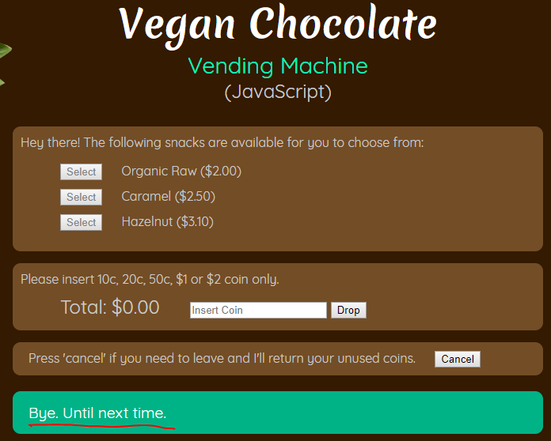

Step 2: Enter “10c”, “20c”, “50c”, “$1” then “$2”. Then enter “cancel”.

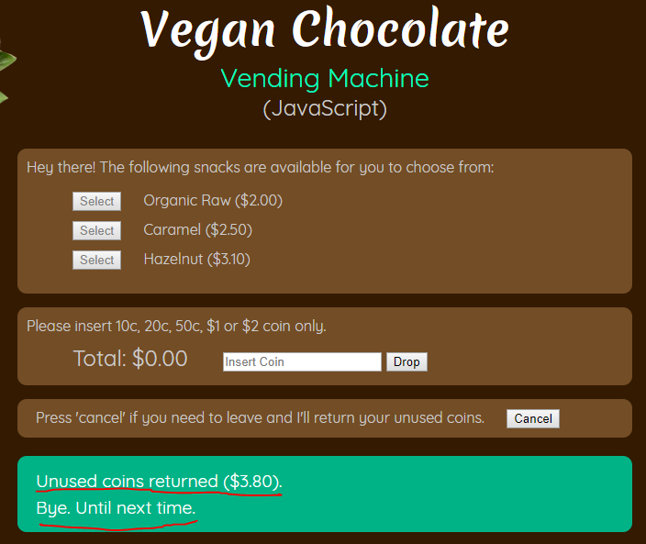

Result:

9.1 - Unused coins are correctly dispensed (if any).

9.2 - Exit message is displayed.

9.3 - New transaction is initiated. Total coin is zero and select buttons disabled.